**FEE TRANSMITTAL**

**For FY 2024 (Effective January 19, 2024)**

**Applicant:** Brian James Rutherford

**Application Number:** To Be Assigned

**Filing Date:** _______________

**Docket Number:** RUTHERFORD-015-PROV

**First Named Inventor:** Brian James Rutherford

**Title:** Quantum Side-Channel Defense System for Post-Quantum Cryptographic Implementation Protection within MWRASP Total Defensive Cybersecurity Platform



**METHOD OF PAYMENT**

* **The Director is hereby authorized to charge the filing fees and credit any overpayment to:**

**Deposit Account Number:** __________ (if applicable)

* **Credit Card** (Form PTO-2038 attached for EFS-Web filing)

☐ **Check**

* **Electronic Payment via EFS-Web (Pay.gov)**



**FEE CALCULATION - PROVISIONAL APPLICATION**

**BASIC FILING FEES**

|  |  |  |  |  |  |  |  |
| --- | --- | --- | --- | --- | --- | --- | --- |
|  | **Fee Code** | **Description** | **Small Entity** | **Micro Entity** | **Quantity** | **Fee Due** | |
| 1013 | | Provisional Application Filing Fee | $160 | **$80** | 1 | **$80** |  |
|  |  |  |  |  |  |  |  |
|  |  |  |  |  |  |  |  |



**ADDITIONAL FEES (if applicable)**

|  |  |  |  |  |  |  |  |
| --- | --- | --- | --- | --- | --- | --- | --- |
|  | **Fee Code** | **Description** | **Small Entity** | **Micro Entity** | **Quantity** | **Fee Due** | |
| 1053 | | Each additional 50 sheets over 100 sheets | $200 | **$100** | 0 | $0 |  |
| 1803 | | Late filing fee or oath/declaration | $80 | **$40** | 0 | $0 |  |
|  |  |  |  |  |  |  |  |
|  |  |  |  |  |  |  |  |

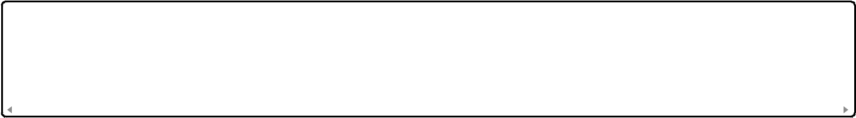

**SEARCH FEES**

Not applicable for provisional applications

**EXAMINATION FEES**

Not applicable for provisional applications



**TOTAL FEES**

**Subtotal:** $80.00

**TOTAL AMOUNT DUE: $80.00**



**ENTITY STATUS**

* **Micro Entity** - Certification attached (Form PTO/SB/15A) ☐ Small Entity

☐ Large Entity

**Note:** Micro entity status provides 75% reduction from standard fees



**CHARGE STATEMENT**

The Commissioner is authorized to:

1. Charge any additional fees required under 37 CFR 1.16 and 1.17
2. Charge any deficiency in fees
3. Credit any overpayment to the deposit account noted above



**SIGNATURE**

A signature of the applicant or representative is required in accordance with 37 CFR 1.33 and 10.18.

**Signature:** /Brian James Rutherford/

**Name:** Brian James Rutherford

**Date:** _______________

**Telephone:** (512) 648-0219

**Registration Number:** N/A (Pro Se Applicant)



**WARNING:** Information on this form may become public. Credit card information should not be included on this form. Provide credit card information and authorization on PTO-2038.